Network Intrusion Detection in VANETS Using Machine Learning: Securing VANETS With Machine Learning- Based NIDS Approach

I. Ravi Prakash Reddy ¹, Akshaya Juluri^{2,} Sanjana Reddy³, Pola Rishika ⁴
¹Professor, Department of Information Technology, G. Narayanamma Institute of Technology and Science for Women Hyderabad, India
irpreddy@test.gnits.ac.in^{1,} juluriakshaya03@gmail.com²,rsanjana090@gmail.com³, rishikapola157@gmail.com³

¹Corresponding Email Id: irpreddy@test.gnits.ac.in
Abstract. In response to the growing cybersecurity challenges in Vehicular Ad Hoc Networks (VANETs), we designed a Network Intrusion Detection System (NIDS) based on machine learning that can better detect malicious threats. The system is based on three main algorithms: Random Forest, XGBoost, Gradient Boosting. These algorithms classify network traffic as normal or malicious. By combining these algorithms, the system exploits their collective strengths, thereby improving the detection accuracy. The NIDS has an alert function that sends notifications about possible intrusions directly to the user's web interface. This approach will improve road safety and traffic management by strengthening vehicular communication security. The system is trained and evaluated using the NLS-KDD dataset for better detection performance in VANET environments.
Keywords: Network Intrusion Detection System (NIDS), Vehicular Ad Hoc Networks (VANETS), NSL-KDD Dataset, Machine Learning Algorithms, Ensemble Learning, Alert Systems.
- Introduction
In the last few years, VANETs have emerged as an important part of smart cities, allowing for advanced communication systems such as V2V and V2I [1]. V2V allows direct communication between vehicles, while V2I connects vehicles to roadside infrastructure, such as traffic lights, optimizing traffic flow and improving road safety [1]. These innovations play a crucial role in developing intelligent transportation systems to reduce congestion, minimize accidents, and have safer roads. Despite these advances, VANETs are susceptible to cyber threats, which compromise communication and potentially endanger driver safety [4]. This vulnerability points to the imperative necessity for stringent security measures that can protect the reliability and integrity of VANETs.
To counter these vulnerabilities, this project introduces the development of a Network Intrusion Detection System (NIDS) especially designed for VANETs. The system uses machine learning algorithms such as Random Forest Classifier, XGBoost, and Gradient Boosting to classify network traffic as either normal or malicious [3]. By integrating these algorithms through ensemble learning, the NIDS benefits from their individual strengths, improving detection accuracy and reducing false positives [7]. They mostly tend to fail to manage computational complexity and dynamic topologies in networks [3-9]
In addition, the system employs an alerting mechanism that keeps the users of any possible intrusions through a simple web inter-face for effective reactions to threats [2].

2 Literature Review
In the year 2023, Adithya and Ravish [8] proposed a VANET-based intrusion detection system to identify false messages in the network. Their paper uses machine learning techniques for the classification and filtering of erroneous communication that originates from malicious sources to ensure network reliability. In the same year, 2024, Palaniappan et al. [9] used an enhanced Dynamic Source Routing (DSR) protocol combined with machine learning methods for the detection of malicious nodes in VANETs. This has improved the detection and isolation of malicious nodes to contribute to a more secure communication environment in VANETs.
In 2023, Kawale et al. [10] proposed a framework for the detection of malicious activity in VANETs by using both traditional detection techniques and modern machine learning algorithms to classify traffic as either normal or malicious.. Meanwhile, in 2021, Gonçalves et al. [11] assessed several VANET datasets in terms of their effectiveness in intrusion detection systems. Their study gives insights into the challenges of using these datasets in real-world scenarios, such as handling large amounts of data.
In addition, in 2021, Ercan et al. [12] proposed a machine learning-based system for detecting position falsification attacks in VANETs. Their work focuses on detecting misbehavior related to position falsification, which can undermine the credibility of communication in VANETs, thereby highlighting the importance of secure and accurate positioning within these networks.

3 Proposed System
The proposed approach for developing a Network Intrusion Detection System (NIDS) in Vehicular Ad hoc Networks (VANETs) follows a structured methodology leveraging ensemble machine learning models. Initially, the dataset is preprocessed by removing duplicates, handling missing values using SimpleImputer, and encoding categorical features with LabelEncoder to ensure numerical compatibility for model training. To address class imbalance, Synthetic Minority Oversampling Technique (SMOTE) is employed to generate synthetic samples for minority classes, enhancing the model's ability to identify rare attack patterns.
Feature selection is performed to extract relevant attributes critical for intrusion detection. The preprocessed dataset is split into training and testing sets using the train_test_split method. Individual machine learning models, including Random Forest Classifier, Gradient Boosting Classifier, and XGBoost Classifier, are trained on the resampled training dataset to capture diverse decision boundaries and enhance predictive accuracy.
The ensemble approach is implemented using a blending technique, wherein class probabilities from each model are aggregated using a weighted average. The final prediction for each instance is determined by selecting the class with the highest probability. The blended model is evaluated comprehensively using metrics such as accuracy, classification report, and confusion matrix to ensure robustness and reliability.
The deployment phase utilizes Streamlit to create an interactive user interface. Users can input data and the system predicts the intrusion category based on user input and displays the results, including alerts for anomalous activity, in an intuitive and user-friendly manner. This integrated approach combines preprocessing, model training, ensemble learning, and deployment to deliver an effective and practical NIDS solution for VANETs.

3.1. PROPOSED MODEL ALGORITHM
Algorithm:

1. Import required libraries pandas, numpy for data handling, LabelEncoder, SimpleImputer, SMOTE for preprocessing, RandomForestClassifier, GradientBoostingClassifier, XGBClassifier for modeling, accuracy_score, classification_report, and confusion_matrix for evaluation, streamlit for deploying the web application.
2. Load and preprocess dataset and remove duplicates, handle missing values, encode categorical data using LabelEncoder.
3.: Extract a subset of features relevant for the model feature selection, set target variable and split the dataset into training and testing sets using train_test_split.
4. Handle class imbalance using Synthetic Minority Oversampling Technique (SMOTE) to generate synthetic samples.
5. Train individual models by initializing the Random Forest Classifier model, Gradient Boosting Classifier model, XGBoost Classifier model and fit each model using the resampled training dataset.
6. For each base model, generate predictions, evaluate their performance and display the evaluation results.
7 Use Ensemble Blending for Final Model:
-Generate class probabilities for each model on the testing dataset.
-Weighted Blending: Combine probabilities using a weighted average formula.
-Final Predictions: select the class with the highest probability for each instance.
8. Evaluate Blended model:
-Compute metrics such as Accuracy, Classification Report, Confusion Matrix and print the evaluation results for the blended model.
9. Deployment using Streamlit:
-Create a user interface, preprocess inputs, predict based on user data, and display results.

4 Results and Analysis

In our work, we developed an Intrusion Detection System (IDS) for Vehicular Ad Hoc Networks (VANETs) leveraging machine learning to enhance security by detecting potential attacks. The system utilized the NSL-KDD dataset and implemented an ensemble approach combining Random Forest Classifier and Gradient Boosting, XGBoost algorithms, capitalizing on their robustness and precision in handling large-scale, imbalanced data. We got an accuracy of 93%, 93%, 95%, 96% for algorithms XGBoost, Random Forest Classifier, Gradient Boosting, and Ensemble approach(Blending) respectively as shown in figures 4.1 (a), (b), 4.2 (a), (b) respectively. The models were trained to classify network traffic as either normal or malicious, with a focus on accurately identifying common VANET attacks. We interfaced the ensemble model with web interface as shown in figure 4.3 (a). Upon detecting an attack, the system triggered an alert message as shown in figure 4.3 (b). This user-friendly interface provides immediate attack alerts to ensure swift action by administrators.

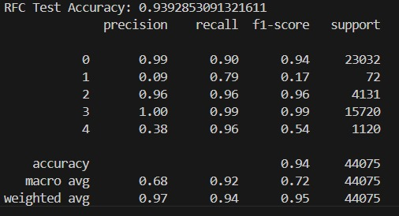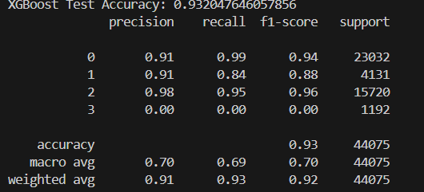
Figure 4.1 (a)Random Forest Classifier model performance metrics (b)XGBoost model performance metrics.
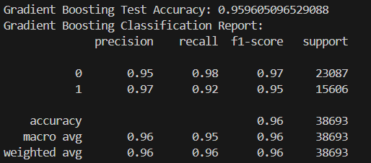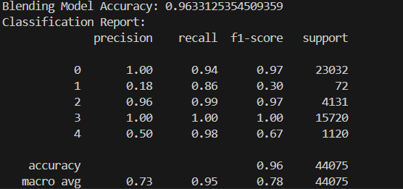
Figure 4.2. (a)Gradient Boosting model performance metrics (b) Ensemble approach (Blending) model performance metrics

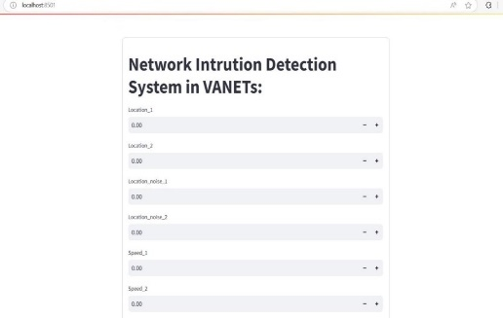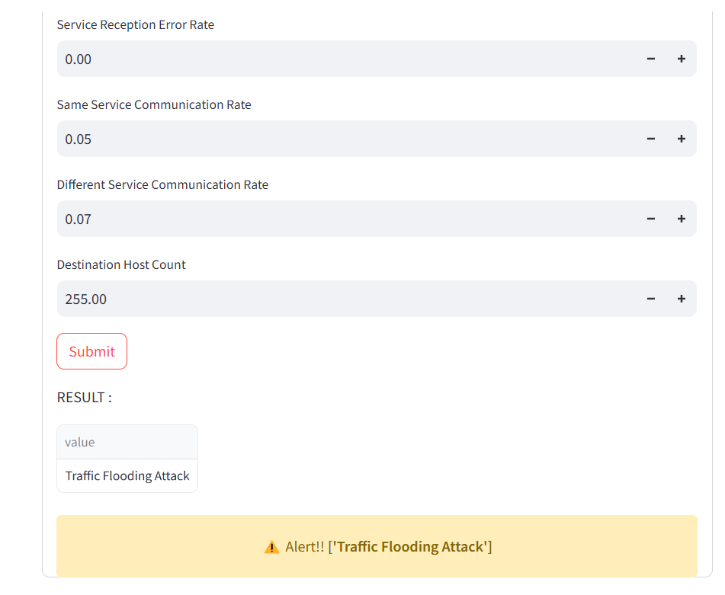
Figure 4.3. (a)Network Intrusion Detection System in Vanet’s Web Interface (b)Alert Message.

5 Conclusion and Future scope
In conclusion, developing a Network Intrusion Detection System (NIDS) for Vehicular Ad Hoc Networks is vital for enhancing the security of transportation systems. Our project utilizes machine learning algorithms to detect and classify the cyberattacks and network traffic efficiently. The use of ensemble learning techniques improves the detection accuracy while also minimizing the false positives. The alert system enables quick responses to security risks. Future developments for the NIDS can utilize real-time data from sensors and other sources to enhance threat detection.

